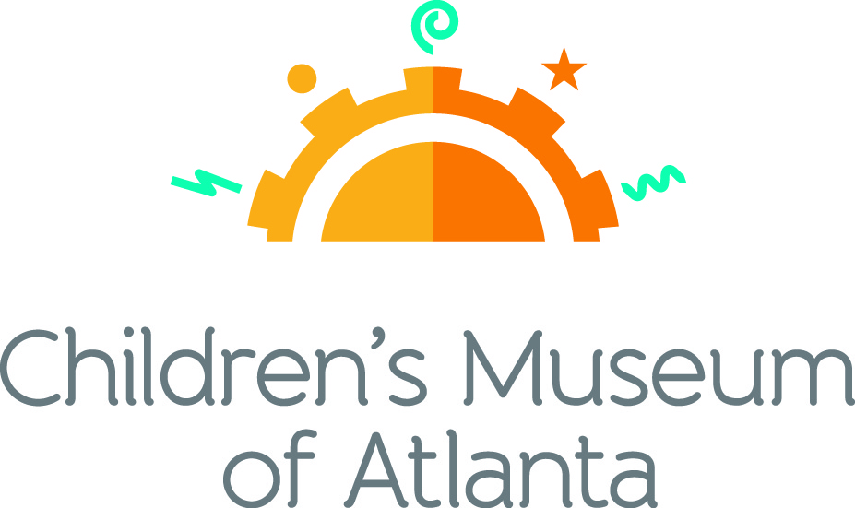

CONTACT
Alison Wentley
BRAVE PR, 404.233.3993
awentley@emailbrave.com

FOR IMMEDIATE RELEASE

Children’s Museum of Atlanta Receives $150,000 Grant from PNC to Extend
Family Free Days
Generous donation ensures no-cost access for next three years
ATLANTA (October 23, 2019) – Children’s Museum of Atlanta will continue to provide free access to resources and experiences that promote learning through the power of play with Family Free Days for the next three years. This program extension was made possible as a result of the generous $150,000 grant from the PNC Foundation. Occurring once every quarter, Family Free Days help give little ones and caretakers of all financial backgrounds the opportunity to visit the Museum at no cost.
“This grant from PNC helps us break down barriers and ensure that every child is afforded the opportunity to explore, learn and grow through the transformative power of play at Children’s Museum of Atlanta,” said Jane Turner, executive director of Children’s Museum of Atlanta. “We are incredibly grateful for the support from our corporate partners who help us continue to extend the reach and impact of our efforts.”

Family Free Days include three two-and-a-half hour sessions per day to maximize attendance, visitor experience and impact. During these special events, the Museum remains open until 6:30 p.m., ensuring parents and kids visiting after work and school are also able to attend. Each quarter, roughly 1,800 guests from all over metro Atlanta come for an admission-free day of fun and education. Family Free Day visitors have the ability to participate in themed educational programming that promotes literacy, STEM, healthy living and social and emotional skills in a festival-like atmosphere.

“We know how important it is to introduce young minds as early as possible to reading and STEM learning through play,” said Eddie Meyers, PNC regional president for Georgia. “This funding for Family Free Days reflects PNC’s continued commitment to helping Children’s Museum provide free, quality early-learning programs to thousands of young families over the next three years.”

Family Free Days take place once every winter, spring, summer and fall. Due to the generous donation from the PNC Foundation, Children’s Museum of Atlanta will have the ability to offer this experience through 2022. For more information or to register, guests are encouraged to visit childrensmuseumatlanta.org.

PNC Foundation
The PNC Foundation, which receives its principal funding from The PNC Financial Services Group (www.pnc.com), actively supports organizations that provide services for the benefit of communities in which it has a significant presence. The foundation focuses its philanthropic mission on early childhood education and community and economic development, which includes the arts and culture. Through Grow Up Great®, its signature cause that began in 2004, PNC has created a $500 million, multi-year initiative to help prepare children from birth to age 5 for success in school and life. To learn more about PNC Grow Up Great, please go to www.pncgrowupgreat.com.
(more)

About Children’s Museum of Atlanta
Children’s Museum of Atlanta is the only educational venue of its kind in Atlanta, presenting educational programs and exhibits designed for young children ages 0-9. The mission of Children's Museum of Atlanta is to change the world by sparking every child's imagination, sense of discovery and learning through the power of play. With six permanent learning zones consisting of bright, creative and hands-on exhibits, the Museum supports inventive play-based exploration and experiential learning focused on the whole child. Core competencies for literacy, math and science are promoted throughout all exhibits and programming in alignment with the state and national Core Performance Standards. Children’s Museum of Atlanta also offers parties, memberships, field trips, summer camp and private events. For more information or to support Children's Museum of Atlanta, visit childrensmuseumatlanta.org or call 404.659.KIDS [5437].

Museum Admission: Plan ahead and save! Families can purchase timed tickets online in advance to save money and guarantee entry to the Museum. Babies under 12 months and members are admitted for free. All daily programs are included in price of admission. Group rates and military discounts are available. For more information regarding ticket and membership options, visit childrensmuseumatlanta.org.

Museum Hours: Monday, Tuesday, Thursday and Friday 10 a.m. – 4 p.m.; Saturday and Sunday 10 a.m. – 5 p.m.; Closed on Wednesdays. Please check the Museum website to confirm hours of operation.

Facebook: facebook.com/childrensmuseumatlanta
Twitter: twitter.com/ChildMuseumATL
Instagram: instagram.com/childrensmuseumatlanta
Pinterest: pinterest.com/cmatlanta

###

